Dog Breed Classifier

**A. Data**

Source - <https://www.kaggle.com/c/dog-breed-identification/data>

You are provided with a training set and a test set of images of dogs. Each image has a filename that is its unique id. The dataset comprises 120 breeds of dogs. The goal is to create a classifier capable of determining a dog's breed from a photo. The list of breeds is as follows:

affenpinscher

afghan_hound

african_hunting_dog

airedale

american_staffordshire_terrier

appenzeller

australian_terrier

basenji

basset

beagle

bedlington_terrier

bernese_mountain_dog

black-and-tan_coonhound

blenheim_spaniel

bloodhound

bluetick

border_collie

border_terrier

borzoi

boston_bull

bouvier_des_flandres

boxer

brabancon_griffon

briard

brittany_spaniel

bull_mastiff

cairn

cardigan

chesapeake_bay_retriever

chihuahua

chow

clumber

cocker_spaniel

collie

curly-coated_retriever

dandie_dinmont

dhole

dingo

doberman

english_foxhound

english_setter

english_springer

entlebucher

eskimo_dog

flat-coated_retriever

french_bulldog

german_shepherd

german_short-haired_pointer

giant_schnauzer

golden_retriever

gordon_setter

great_dane

great_pyrenees

greater_swiss_mountain_dog

groenendael

ibizan_hound

irish_setter

irish_terrier

irish_water_spaniel

irish_wolfhound

italian_greyhound

japanese_spaniel

keeshond

kelpie

kerry_blue_terrier

komondor

kuvasz

labrador_retriever

lakeland_terrier

leonberg

lhasa

malamute

malinois

maltese_dog

mexican_hairless

miniature_pinscher

miniature_poodle

miniature_schnauzer

newfoundland

norfolk_terrier

norwegian_elkhound

norwich_terrier

old_english_sheepdog

otterhound

papillon

pekinese

pembroke

pomeranian

pug

redbone

rhodesian_ridgeback

rottweiler

saint_bernard

saluki

samoyed

schipperke

scotch_terrier

scottish_deerhound

sealyham_terrier

shetland_sheepdog

shih-tzu

siberian_husky

silky_terrier

soft-coated_wheaten_terrier

staffordshire_bullterrier

standard_poodle

standard_schnauzer

sussex_spaniel

tibetan_mastiff

tibetan_terrier

toy_poodle

toy_terrier

vizsla

walker_hound

weimaraner

welsh_springer_spaniel

west_highland_white_terrier

whippet

wire-haired_fox_terrier

yorkshire_terrier

B. Preprocessing

**1 Resize and normalize data**

We define the new image size applied for all images

All the images do not have the same shape. For our model, we need to resize them to the same shape. We use the common practice to reshape them as a square. We also need to normalize our dataset by dividing by 255 all the pixel values. The new pixels values will be in the range [0,1].

Let’s check one image from the training dataset:

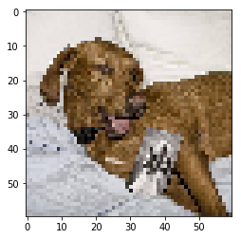

**2 Extract the most represented breeds**

We will reduce the database so that we can reduce the complexity of our model. In addition, it will help for the calculation as there will be only N breeds to classify.

**2 One-Hot Labels**

We did one-hot encoding for our labels data.

c. The Model:

**CNN with TensorFlow — Defining Layers**

The architecture will be like this:

* 1st Convolutional Layer with 32 filters
* Max pooling
* Relu
* 2nd Convolutional Layer with 64 filters
* Max pooling
* Relu
* 3rd Convolutional Layer with 128 filters
* Max pooling
* Relu
* DropOut
* Flatten Layer
* Fully Connected Layer with 500 nodes
* Relu
* DropOut
* Fully Connected Layer with n nodes (n = number of breeds)

**Google each of them and write a short piece of about three sentences each to explain**

From a bigger picture, a CNN architecture accomplishes 2 major tasks: feature extraction (convolution + pooling layers) and classification (fully-connected layers).

Model Hosting

Model is hosted with Nanonets

Because the NanoNets models are heavily pre-trained, We made a few modifications to the data From this model, we got 99.3% test accuracy. This is 5% more than the original model in spite of adding just 1/60th of the data! The reason that NanoNets model performs better is:

large amount of pre-training,

optimal hyper-parameter selection,

and data augmentation.

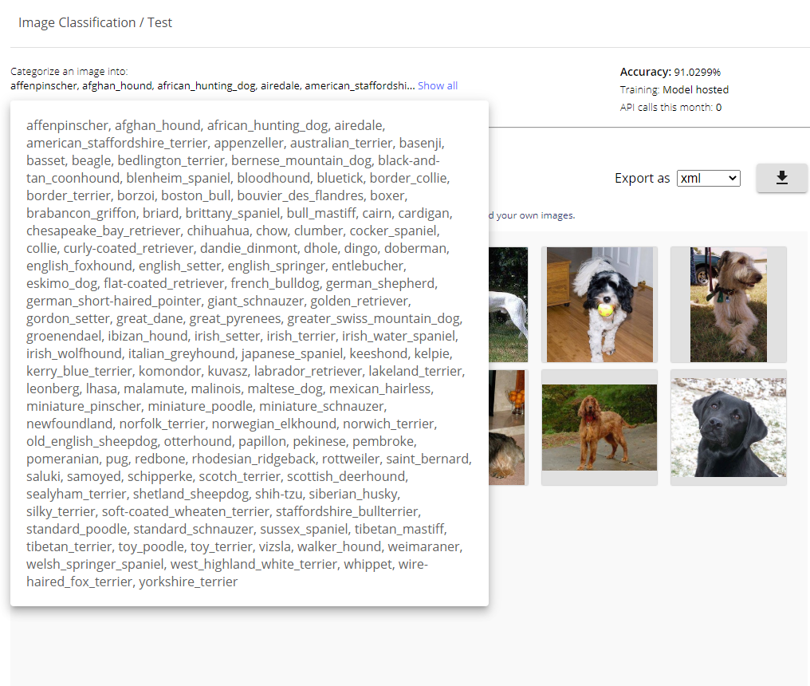

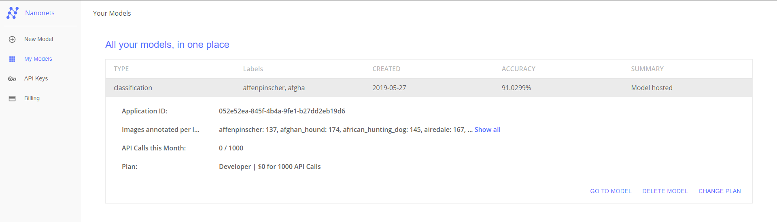

D. Accuracy/Evaluation

We split our train data in two: a training set and a validation set. Therefore, we can check the accuracy of the model train made from the ‘training set’, on the validation set.

Original CNN Model

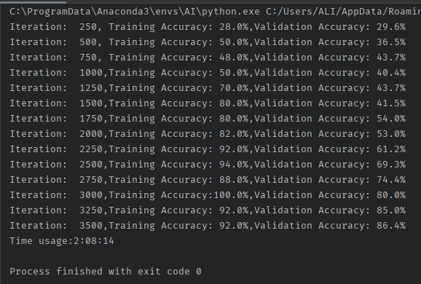

Hosted CNN Model on Nanonets

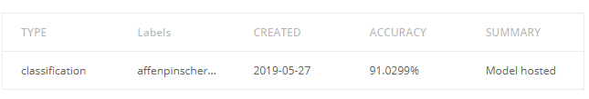

4. Implementation

